Experiment 6 – Cursor Based Row Processing in PL/pgSQL

Student Name: Sahil Goyal
UID: 24BDA70148
Branch: CSE
Section/Group: AIT-KRG-GP2
Semester: 4th
Date of Performance: 27/02/26
Subject Name: DBMS

Experiment
Experiment 6: Implementing implicit cursors, explicit cursors, and cursor attributes in PL/pgSQL to process employee records row by row.
This experiment demonstrates how PostgreSQL handles query results internally and how programmers can manually control row-by-row processing using cursors

Aim
To understand and implement cursors in PL/pgSQL for processing multiple rows from a database table one record at a time.

Objective
- To understand the concept of cursors in PostgreSQL.
- To implement implicit cursors for DML operations.
- To implement explicit cursors to fetch multiple records from a table.
- To use cursor attributes such as FOUND, NOT FOUND, and row counters.
- To process and display employee records using RAISE NOTICE.

Software Requirements
- Database: PostgreSQL
- Tool: iterm2

Practical / Experiment Steps
- Create an Employee table and insert sample records.
- Write a PL/pgSQL block to demonstrate implicit cursor behavior using an UPDATE statement.
- Declare and use an explicit cursor to fetch employee records one by one.
- Use a loop structure to process each row retrieved from the cursor.
- Apply cursor attributes to control loop execution and count processed rows.
- Display employee details using RAISE NOTICE.
- Take screenshots of outputs for documentation.

Input / Output Details

Input
- emp_id INT
name VARCHAR(50)
salary INT
- Operations performed:
- Updating employee salary
- Fetching employee records using cursors
- Counting processed rows

Output
- Step 1: Display message indicating whether employee salary update was successful.
- Step 2: Display employee details fetched using an explicit cursor.
- Step 3: Display employee ID, name, and number of rows processed using cursor attributes.

SQL / PL/pgSQL Code
1.IMPLICIT CURSOR
DO $$
BEGIN
UPDATE Employee
SET salary = salary + 1000
WHERE emp_id = 1;

IF FOUND THEN
RAISE NOTICE 'Employee salary updated successfully.';
ELSE
RAISE NOTICE 'Employee not found.';
END IF;
END $$;

2.EXPLICIT CURSOR
DO $$
DECLARE
emp_cursor CURSOR FOR
SELECT emp_id, name, salary FROM Employee;

emp_record RECORD;

BEGIN
OPEN emp_cursor;

LOOP
FETCH emp_cursor INTO emp_record;
EXIT WHEN NOT FOUND;

RAISE NOTICE 'Employee ID: %, Name: %, Salary: %',
emp_record.emp_id,
emp_record.name,
emp_record.salary;

END LOOP;

CLOSE emp_cursor;
END $$;
3.CURSOR ATTRIBUTE
DO $$
DECLARE
emp_cursor CURSOR FOR
SELECT emp_id, name FROM Employee;

emp_record RECORD;
row_counter INT := 0;

BEGIN
OPEN emp_cursor;

LOOP
FETCH emp_cursor INTO emp_record;
EXIT WHEN NOT FOUND;

row_counter := row_counter + 1;

RAISE NOTICE 'Employee ID: %, Name: %',
emp_record.emp_id,
emp_record.name;

RAISE NOTICE 'Rows processed so far: %', row_counter;

END LOOP;

CLOSE emp_cursor;
END $$;

Screenshots
- Screenshot 1:Execution of implicit cursor program showing update result.
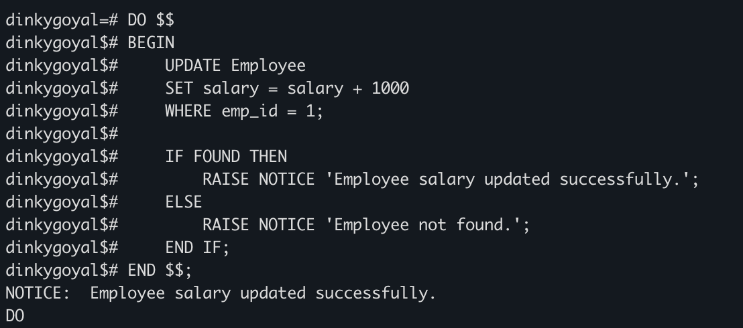
- Screenshot 2: Output displaying employee records fetched using explicit cursor.
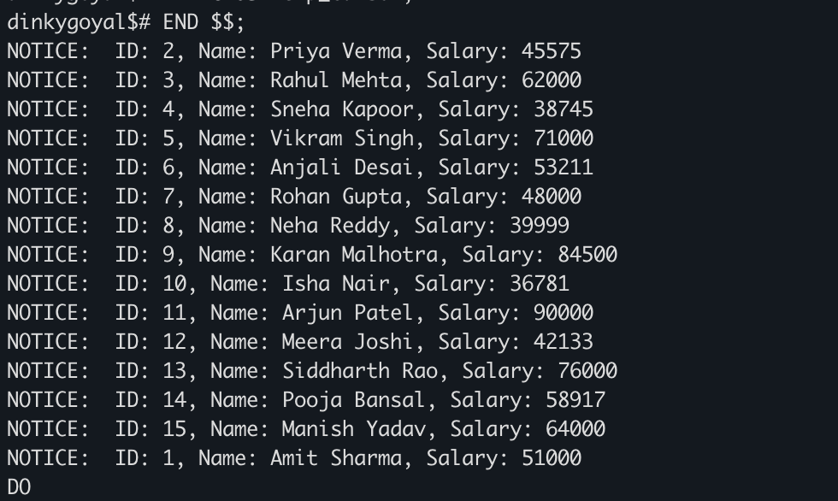

- Screenshot 3: Output displaying employee details along with number of rows processed using cursor attributes.
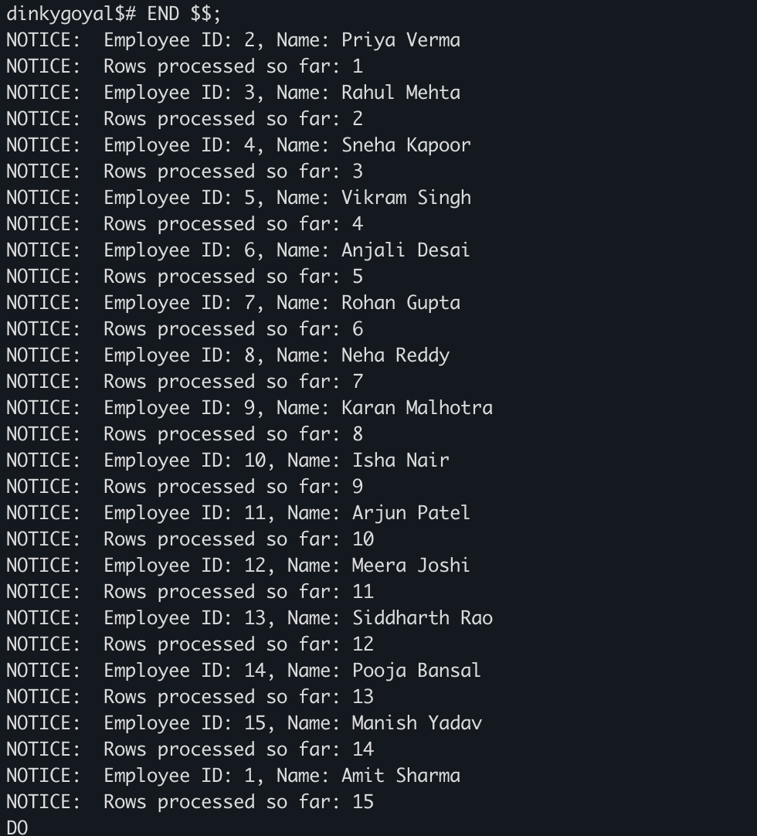

Learning Outcome
- Learned the concept and importance of cursors in PL/pgSQL.
- Understood the difference between implicit and explicit cursors.
- Learned how to fetch records one by one from a table.
- Learned how to use cursor attributes such as FOUND and NOT FOUND.
- Gained practical knowledge of row-by-row data processing in PostgreSQL.

